In his welcome to Mr. Philippe Le Houérou at this first working visit to Vietnam as CEO of the IFC, Governor Le Minh Hung wished him a successful business trip, thereby helping to strengthen the long-term relationship between the IFC and the Government of Vietnam.
The Governor expressed his gratitude for the support of the World Bank Group in general and the IFC in particular to Vietnam over the past time, which has made an important contribution to Vietnam’s socio-economic development. According to Governor Le Minh Hung, presently in Vietnam, there is a huge demand for development investment, therefore the IFC's financial and capital resources, especially its initiatives and new financial instruments, are considered to be a much needed financial channel, contributing to support the implementation of the economic development plans set out by the Government of Vietnam.
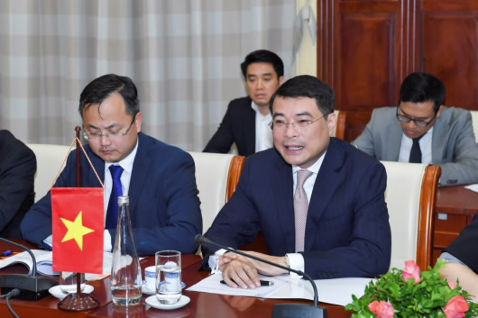
Governor Le Minh Hung welcomes Mr. Philippe Le Houérou, CEO of the IFC
As for the banking sector, the IFC has been considered a major investor, a companion, who has contributed significantly to the development of the entire banking system in Vietnam. Governor Le Minh Hung highly appreciated the technical support that the IFC had provided to the SBV over the past time and said that currently, there is a big demand for the IFC’s technical support from the SBV entities. Therefore, the SBV hopes that the IFC will continue to provide its support, as well as call for fundings from other international institutions, to contribute to the cause of strengthening and improving the performance of Vietnam's banking industry.
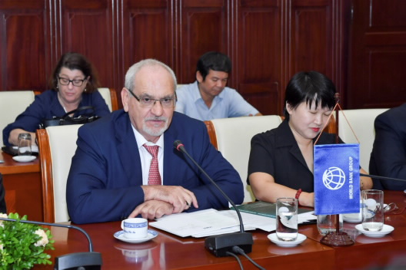
Mr. Philippe Le Houérou is impressed with the recent achievements of Vietnam.
Expressing his sincere thanks to Governor Le Minh Hung for his time to meet the IFC Mission, Mr. Philippe Le Houérou mentioned his positive impressions by the recent achievements of Vietnam, one of the fastest growing economies in the world with increasing growth of the production and business facilities, together with a young and dynamic workforce. In the banking sector, the SBV has actively and flexibly regulated the monetary policy to curb the inflation efficiently, making an important contribution to the macroeconomic stability and enhancing the business development.
Also at the meeting, when discussing on the private sector, Governor Le Minh Hung and Mr. Philippe Le Houérou affirmed the key role of the private sector in the national economic development, which is an important foundation contributing greatly to Vietnam’s economy. Governor Le Minh Hung and Mr. Philippe Le Houérou also exchanged their views on the public debt management and Vietnam’s demand for infrastructure investment; discussed about the IFC’s offer to provide finance to the renewable energy area, and the cooperation between the IFC and the local provinces in Vietnam.
Talking about the IFC’s offer to issue international bonds in VND to attract capital flows for long-term investment activities in Vietnam, SBV Governor Le Minh Hung and Mr. Philippe Le Houérou emphasized that this is a great initiative, and should it be implemented, it would help the domestic enterprises to access the long-term capital resources and the technology from the IFC without taking the exchange rate risks.
Thoa Le

