Press Release on change of SBV logo
On the occasion of 65th anniversary of Vietnam National Bank (May 6, 1951 – May 6, 2016), the Governor of the State Bank of Vietnam (SBV) issued Decision No. 1639/QĐ-NHNN on August 19 to approve the new logo of the SBV.
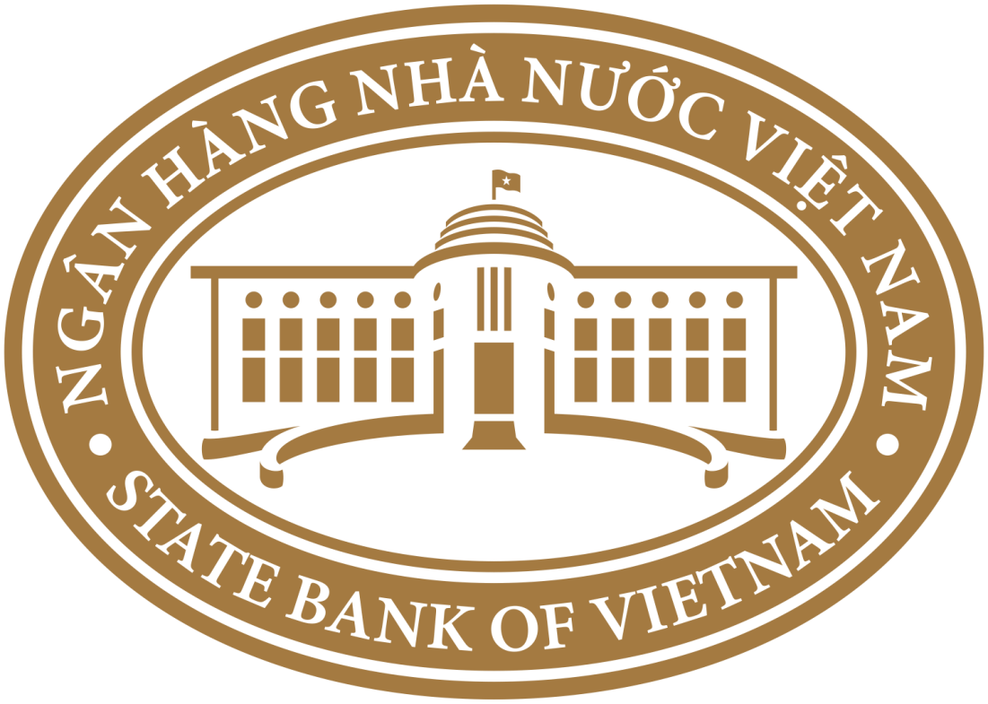

The logo is designed with solemn and well – proportioned features, and the stylized image of the building of SBV Head quarter in the center to represents the outstanding role and mandate of the SBV in state management of monetary sector and banking operations. The color associate with the Logo gives the expression of the reliability, stability and sustainable development of the Banking sector.
The change of SBV Logo together with the formulation of SBV brand identity is an important step to develop the SBV toward a modern central bank which inherits and builds up its traditional values.
VMH

