At the ceremony, Mr. Dang Van Tuyen, Director General of the Human Resource Department, announced Decision No. 226/QD-NHNN dated February 25, 2022 of the SBV Governor appointing Mr. Doan Ngoc Luu as Deputy Director General of the Internal Audit Department. His office tenure is five (05) years, starting from March 1, 2022. Mr. Doan Ngoc Luu was previously Director of Agribank – Thang Long branch.
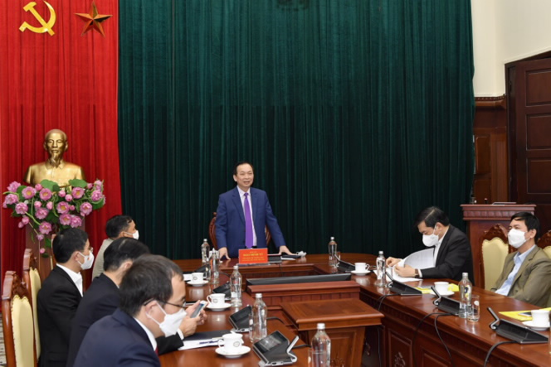
Deputy Governor Dao Minh Tu speaks at the ceremony
Speaking at the ceremony, Deputy Governor Dao Minh Tu congratulated Mr. Doan Ngoc Luu on his appointment. He expressed his hope and beliefs that Mr. Doan Ngoc Luu would continue to develop his capacity, wisdom, experience, and the sense of responsibility to accomplish the assigned tasks in his newly appointed position.
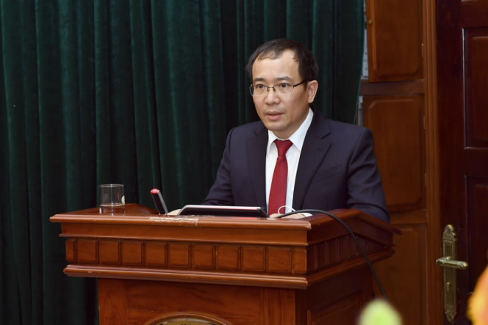
Mr. Doan Ngoc Luu speaks at the ceremony
In his statement of gratitude, Mr. Doan Ngoc Luu promised to do his best to contribute to the development of both the SBV and the banking sector.
Le Hang

