Also attending the meeting, there were representatives from the Monetary Policy Department, the Department of Credit for Economic Sectors, and the Department of Legal Affairs of the SBV.
At the meeting, Deputy Governor Pham Thanh Ha shared about the economic performance of Vietnam in the first quarter of 2022, with the significant results in the credit growth. The SBV Deputy Governor also made high evaluation of the cooperative relationship between Vietnam and the ADB, especially the ADB’s loans for the private sector and its initiative of funding the climate-related projects (the ASEAN Green Catalytic Financing Facility (AGCF), and the Energy Transaction Mechanism (ETM)).
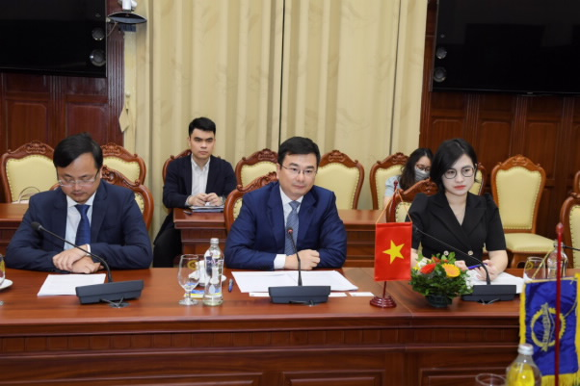
Deputy Governor Pham Thanh Ha speaks at the meeting
For his part, Mr. Ramesh Subramaniam, Director General of the ADB's Southeast Asia Regional Department, expressed his pleasure with the encouraging results from the partnership between the ADB and Vietnam, and hoped for further cooperation with Vietnam in the coming time. He shared about the objectives of the Country Partnership Strategy for Vietnam (2023-2026), focusing on the ADB’s support for climate-related projects and the ADB’s loans to the private sector. With the policy of “One ADB”, the Bank hopes for more effective coordination between the public and the private sectors in the ADB’s activities in the future.
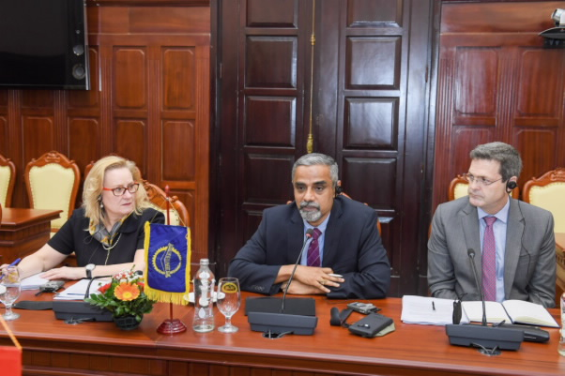
ADB Directors General speak at the meeting
Regarding the activities for the private sector, Ms. Suzanne Gaboury, Director General of the ADB’s Private Sector Operations Department, made high evaluation of the achievements in this area. In addition, she also shared about the existing obstacles in the private sector engagements of the ADB in Vietnam. Ms. Suzanne suggested several new orientations for the development of the private sector in Vietnam, such as contributed capital investment, healthcare services, green development, products related to the domestic currency, etc.
Le Hang

