Attending the Seminar, there was Mr. To Huy Vu, Director General of the International Cooperation Department; Ms. Nguyen Thi Thu Huong, Deputy Director General of the Issue and Vault Department, together with other officers from the relevant SBV entities.
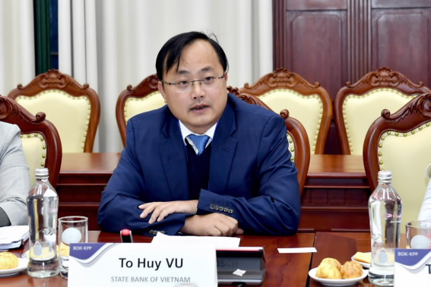
Mr. To Huy Vu, Director General of the International Cooperation Department, at the Seminar
On the BOK’s side, there was Mr. Byung Wha Jang, former Deputy Governor of the Bank of Korea (BOK), and currently Senior Advisor of the BOK-Knowledge Partnership Program (BOK-KPP) in 2023; representatives from the BOK’s International Affairs Department; Mr. Young Han Kim, Head of the Advisory Team of the 2023 BOK-KPP and Professor at Sungkyunkwan University; experts and officers of the BOK-KPP.
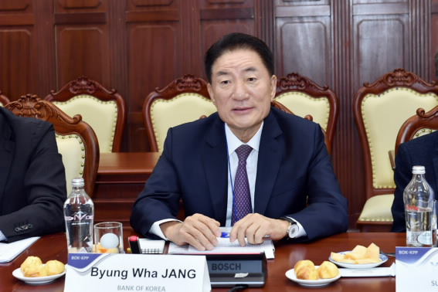
Mr. Byung Wha Jang, former Deputy Governor of the BOK
At the meeting, the representatives from the BOK’s side presented to and discussed with the SBV’s side such topics as i) Characteristics of cash structure in Vietnam; (ii) Characteristics of the models and methods for forecasting cash demand of the BOK; (iii) How to improve the models of forecasting cash demand in Vietnam; (iv) Macro-economic impacts of changes in cash demand and impacts on cash issuance policy.
On that basis, the two countries' research teams focused on exchanging and improving the contents of the Advisory Report, assessing the feasibility of the recommendations and proposals stated in the Report in order to further improve the quality of analysis and forecasting activities in general, and cash demand forecasting in particular at the SBV.
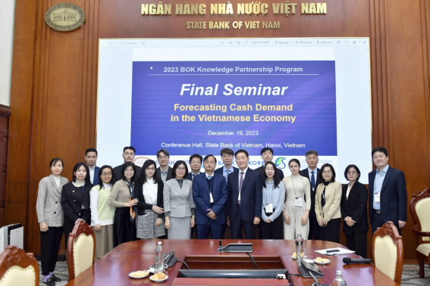
The participants take a group photo at the Seminar
Speaking at the Seminar, Mr. To Huy Vu, Director General of the SBV International Cooperation Department, highly complimented the efforts of the professors and the members of the two countries' research teams during the past 6 months. Mr. Vu hoped and expressed his beliefs that the participants would continue to exchange their views actively and effectively to improve the recommendations, and clarify the obstacles in the process of transferring the models, etc. In addition, Mr. Vu highly acknowledged that the experts had used different methods, while still paying attention to Vietnam's unique characteristics, applying many new methods, tools, as well as models to get good results. This is an opportunity for the SBV officers to work along with the Korean professors and experts, to improve their knowledge, experience and capabilities in analyzing and forecasting.
Le Hang

