In his opening speech, Deputy Governor Pham Tien Dzung, First Vice Chairman of the Steering Committee for Digital Transformation of the Banking Sector, said that the world has been experiencing a period of remarkable transformations driven by several key technologies and innovations associated with the Fourth Industrial Revolution (IR4.0). Among them, the most outstanding is Artificial Intelligence (AI) - a breakthrough technology that has been making profound impacts on many industries, sectors, and aspects of life and work, with the potential to reshape the banking sector in the digital era, lifting the digital transformation of the banking sector to a new height.
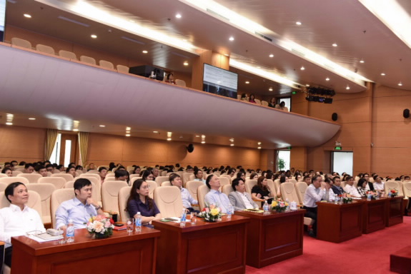
Participants at the Seminar
The SBV Deputy Governor hoped that the participants in the Seminar would actively discuss and share information to clarify the impacts, opportunities and risks of the artificial intelligence on the central banking operations and the work force in the sector, thereby coming up with possible solutions to limit the risks and the negative impacts, while leveraging the positive advantages of AI, with the special focus on training and retraining of digital knowledge and skills for the union members and employees in the banking sector to adapt to and work effectively in an environment where AI presence is becoming increasingly visible. In addition, this Seminar would be a premise for the trade union officials and members to come up with more new ideas and initiatives to improve their work performance, as well as to enhance the quality of their advisory inputs and proposals to the SBV’s Board of Management.

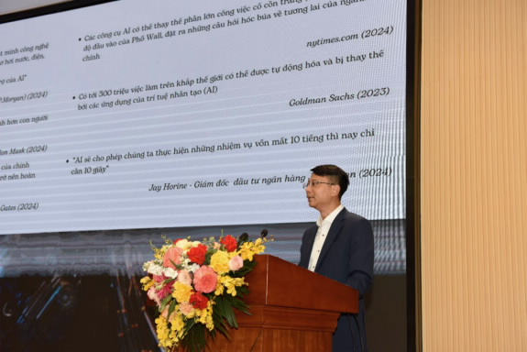
Mr. Le Anh Dzung, Deputy Director General of the SBV Payment Department, speaks at the Semiar
Delivering a general presentation about the banking sector in the era of AI, Mr. Le Anh Dzung, Deputy Director General of the Payment Department, affirmed the big potentials, opportunities and significant impacts of Generative AI (GenAI) on the banking sector and the working environment in the future. The big impacts of AI raises the necessity of trainning and retrainning of digital knowledge and skills in general, and of AI in particular. Training should start from the entities’ leaders to each union member. AI, especially GenAI, has affected most of the aspects of the banking operations. In the future, the banking sector will have a lot of opportunities working with AI, in which humans hold a central position in all aspects of implementing AI, from designing, implementation, management, and supervision.
Also at the Seminar, Mr. Nguyen Trung Anh from the Payment Department delivered a presentation on GenAI’s applications in work to improve the labor productivity, particularly the existing free AI products can help banking staff save time in their fundamental jobs and operations. However, the representative of the Payment Department also called the audience’s attention to the need for distinguishing, and filtering the information generated by AI.
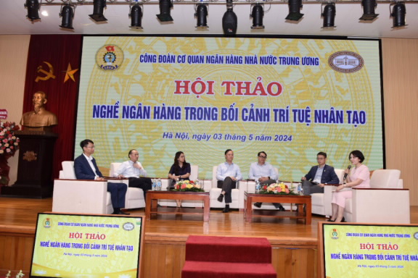
Representatives of the SBV entities participate in the dialogue session at the Seminar
At the dialogue session of the Seminar, the panelists further clarified the importance of AI, and AI’s applications in the professional operations, as well as the need for improving the knowledge about AI among the banking employees in the current context.
HY

